Acetylene fact & safety sheet

Contents
1. Handling & working with acetylene 2
1.1. Basic information 2
1.2. Acetylene with Oxygen 2
1.3. Acetylene with materials 2
1.4. High Pressure equipment: 3
2. Reactivity of acetylene 4
2.1. Basic information 4

Handling & working with acetylene

Basic information
- Its handling, especially under pressure, also needs a sound basis in high-pressure engineering technology.
- Special care has to be taken can also be ascribed to thermodynamics and the high energy content of the unstable molecule.
- Safely working with acetylene: Miller, S. A. AcetyleneIts Properties, Manufacture and Uses, Vol. 1; Ernest Benn: London, 1965; Technische Regeln fur Acetylenanlagen und Calciumcarbidlager; Deutscher Acetylenausschuß, B. F. A. U. U., Dortmund, Ed.; 1969.
- Hence, the experimentalist should always be careful and perform experiments only in a cubicle that is sufficiently armored against blasting of the equipment.
- Its high reactivity toward oxygen; (2) its high tendency to form explosive acetylides; and (3) its thermodynamic instability and the tendency to decompose into the elements
- Explosive acetylide ions can be controlled when wet and destroyed with nitric acid by warming

Acetylene with Oxygen
- The presence of oxygen or air has to be excluded, as explosive mixtures of air and acetylene are formed between 2.5 and 82 vol % of air in acetylene and the energy required for decomposition is strongly influenced by the presence of oxygen.
- In the case of deflagration, the pressure increase would be 11-fold. In the case of mixtures of pure oxygen and acetylene, the upper explosive limit is extended to 93% oxygen in acetylene and the pressure increase is 50-fold : In laboratory use, this issue can be overcome by excessive purging with inert gas.
- However, the connection to the acetylene bottle has to be secured by a flame arrester and not only by a check valve in any case

Acetylene with materials
- The formation of explosive acetylides can be avoided by the proper choice of suitable materials, which does not allow the use of copper- or silver-containing equipment, since the acetylides of these elements are especially problematic. In case of copper, the TRAC restricts the use of materials containing more than 65% Cu
- One should completely avoid the use of brass or other materials containing metals that form reactive acetylides. However, in a wet state copper acetylide is not prone to explosion
- The materials used for reactors and other equipment in contact with gaseous acetylene should be either steel that does not contain any alloy components except carbon or highly alloyed stainless steel.

High Pressure equipment
- The good solubility of acetylene in several solvents (e.g., methanol) provides the possibility to investigate certain reactions with an acetylene pressure higher than 1.5 bar, even if it is taken from a typical container. This procedure¹ for using pressurized acetylene at pressures up to 50 bar for reactions has been used in our laboratory without problems
- Because of the high solubility of acetylene in the solvent even at high temperatures, the pressure of gaseous acetylene does not give clear information about the amount of acetylene in the system without knowledge of the solubility of acetylene under the applied conditions
- These compressors should operate with a low stroke speed in order to avoid a sudden pressure increase, although in an oxygen-free atmosphere there is little concern about decomposition upon a pressure surge
- The most important design rule for the equipment used is a pressure tolerance up to at least the pressure P* given by eq 1, which is based on the measurement of the pressure increase upon acetylene decomposition:
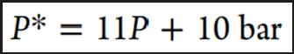
Where P is the maximum working pressure in bar. I.E, if one wants to work under an acetylene pressure of 25 bar, the whole setup needs to be able to tolerate a pressure of almost 300 bar
- The use of short pipes with a small inner diameter is advisable because the detonability limits are strongly dependent on these parameters
- One also must account for the temperature (i.e., the condensation curve) in order to avoid condensation and the formation of liquid acetylene, which is considered as a serious danger. The temperature of the acetylene must be monitored, and the compression needs to be stopped if the temperature falls below a certain value at a given pressure

[1] Acetylene in an autoclave that contains a suitable solvent at the temperature of a dry ice/methanol bath

Reactivity of acetylene

Basic information
- Strongly endergonic, Δ Hformation = 226 Kj/mol : even with highly unreactive molecules such as water or carbon dioxide, overall reactions always tend to be thermodynamically favored.

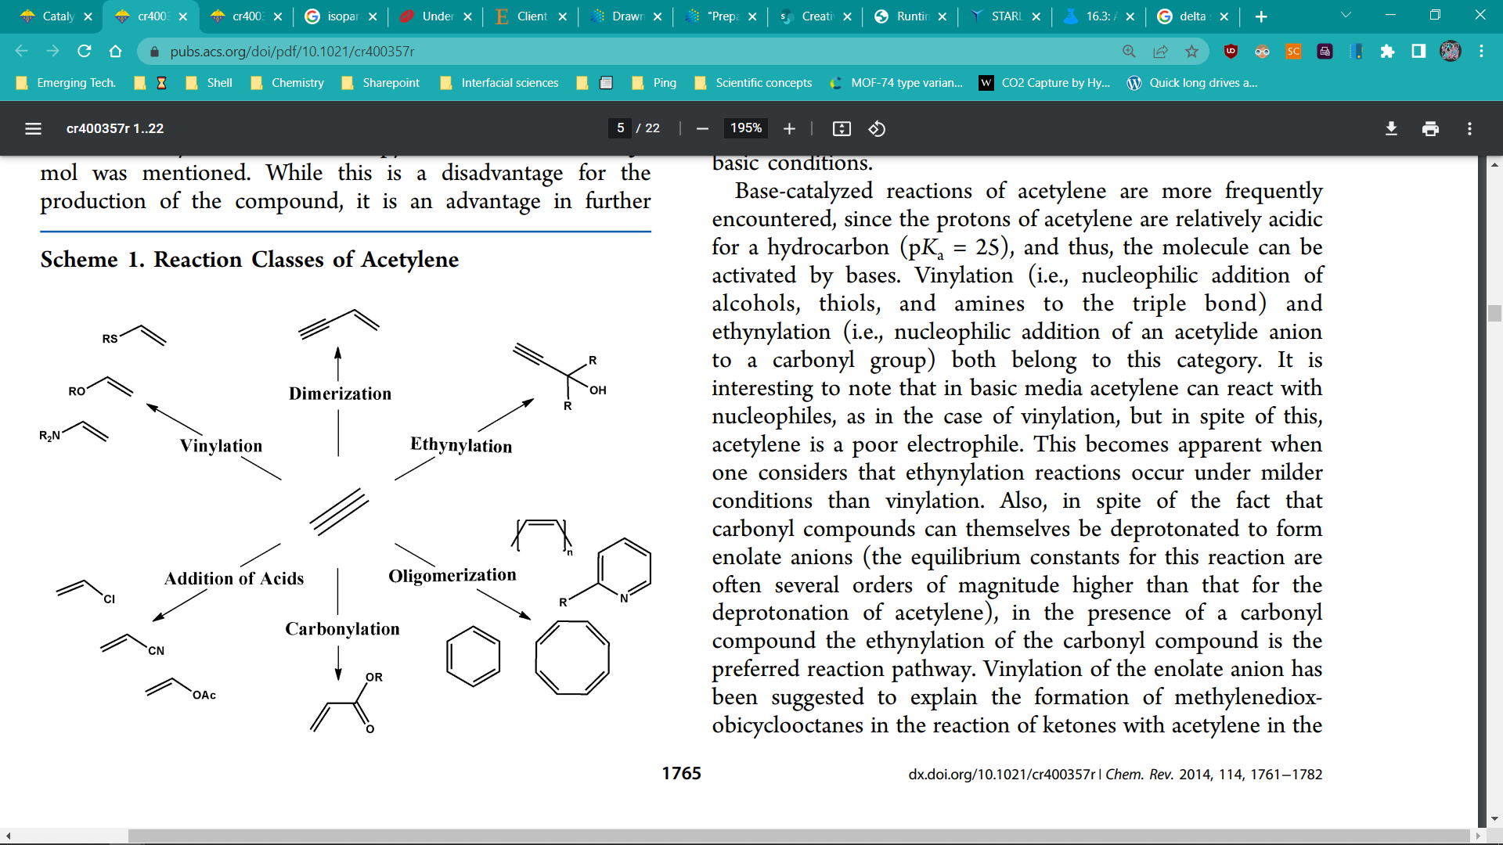
Figure 1. Reaction classes of acetylene

- Acetylene is expected to have very high reactivity and are generally exothermic.
- Its high reactivity is confirmed by the ease with which acetylene decomposes to form coke and hydrogen. A rather general observation, which holds for almost any surface, is the high tendency of acetylene, once adsorbed, to form coke. Coking is also one of the major drawbacks under ambient conditions for almost all reaction classes. However, it is interesting to notice that there are differences with respect to coke formation on different surfaces
- Consequently, surface science studies might give some hints for reducing deactivation by coke formation
- The reaction of benzene (1) and ethene (2) to generate ethyl benzene (3), illustrated in eq 1, is calculated to be exothermic with ∆H(0 K) ) -21.7 kcal/mol and ∆H(289.15 K) ) -23.9 kcal/mol, which corresponds very well to the experimental value of ∆H(289.15 K) ) -25.2 kcal/mol.18 We calculate ∆G(289.15 K) ) -15.4 kcal/mol, very close to the experimental value of -16.1 kcal/mol.1

Acetylene & ethylene chemistry (Alkylation)

Ion formation
The alkylation of benzene or aromatics with ethylene over acidic zeolites takes place via the generally accepted carbenium ion (CH2+) mechanism. Based on this mechanism, the ethylene is protonated over the Bronsted acidic sites to a carbenium ion (tricoordinated carbon atom). Its electrophilic attack on the aromatic ^-electrons generates a mono- or polyalkylbenzenium ion. The desorption of the latter intermediate and loss of the proton results in the gas phase alkylated aromatic and the restoration of the Br0nsted acid site.
NOTE
A Brønsted acid site can only undergo hydrogen bonding (O−H···O) if:
(i) there is a proximity between framework oxygen atoms and
(ii) the geometry between the bridging hydroxyl group (SiOHAl) and the other framework oxygen atom is suitable.
The bridging hydroxyl group (OH, the hydrogen bond donor) must be targeted toward a nearby framework oxygen atom (O, the hydrogen bond acceptor). Unfortunately, zeolite Y is one of the few zeolites for which the hydrogen atoms were located by neutron diffraction analysis [1]

Alkylation
Smirniotis and Ruckenstein have reported that the alkylation of bulky aromatics with relatively large alkylating agents over small or medium pore zeolites occurs via a Langmuir-Hinshelwood (LH) mechanism, while the alkylation of relatively small aromatics over large pore zeolites follows the Rideal-Eley (RE) mechanism [2].
In fact, different experimental studies have concluded that the mechanism of benzene ethylation catalyzed by H-ZSM-5 is best described by a LH mechanism, in which the initial step is the co-adsorption of the reactants at the acid site
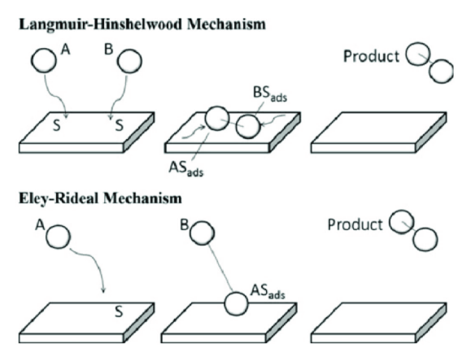
Figure 2. Alkylation surface mechanism on zeolites
Neutron, Raman and X-ray diffraction measurements as well as Monte Carlo simulations show that the channel intersections are the preferred sites for benzene adsorption for loadings up to 4 molecules per unit cell. Since the pore size of H-ZSM-5 closely matches the dimensions of the reaction product, ethylbenzene, it can be assumed that the formation of this product occurs preferentially on acid sites located in the channel intersections. Mechanistic studies of benzene alkylation on different zeolites suggest that the olefin and benzene do not compete for adsorption on the acid site. The olefin is assumed to interact with the Brønsted acid site, while benzene adsorbs edge-on next to the adsorbed olefin. The protonated olefin then reacts with the more weakly adsorbed benzene to form alkylbenzene. However, mechanistic details involved in going from the reactants to the final products are not well understood.
Relating to multiple alkylation steps:
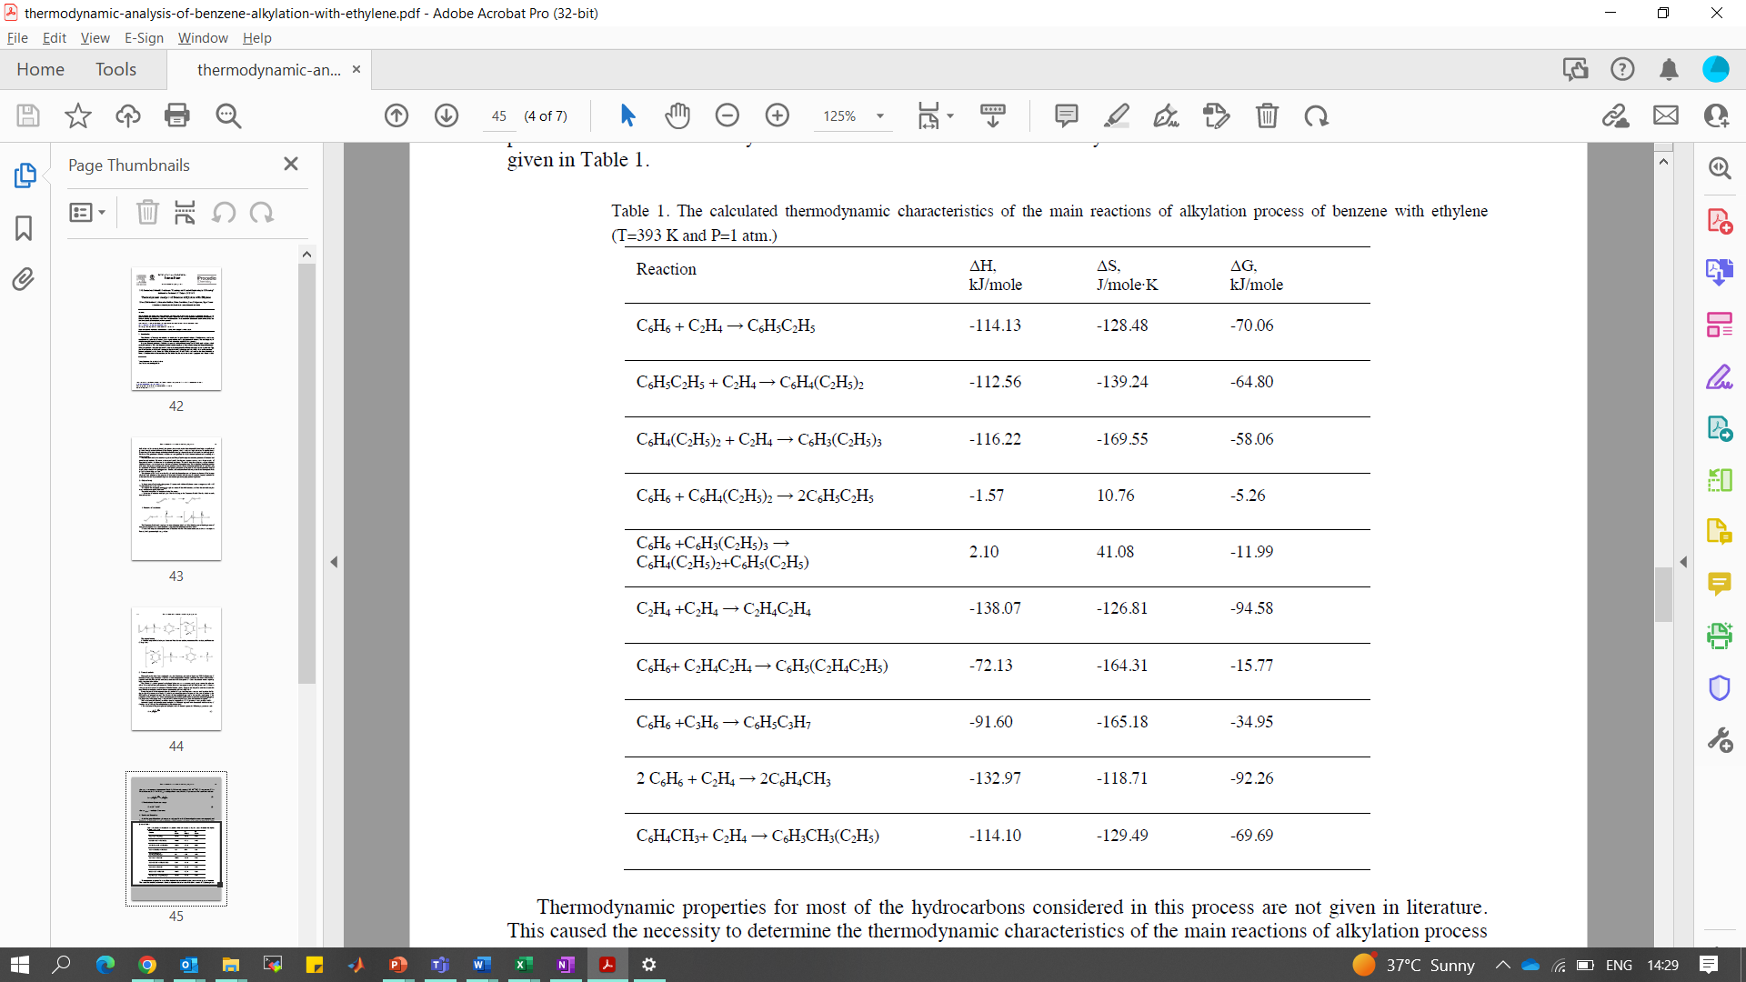
Alkylation to EB
Second Alkylation to EB
Third Alkylation to EB
Transalkylation
Transalkylation
Oligomerization
Oligomerization alkylation
Alkylation to toluene
Alkylation ON TOLUENE
Benzene
Ethy
EB

Bibliography

[1] | V. S. C. M.-L. M. H. M. R. H. a. H. K. Christian Schroeder, "Hydrogen Bond Formation of Brønsted Acid Sites in Zeolites," Chem. Mater., p. 1564–1574, 2020.
[2] | T. B. A. T. B. a. F. J. K. Niels Hansen, "Theoretical Investigation of Benzene Alkylation with Ethene over H-ZSM-5," J. Phys. Chem. C, 2008.

